**Test Case 0003**

**System:** Bench

**Description:** Test that the matching is implemented correctly.

**Severity:** 3

**Instructions**

**Test1**

1. Start the Bench application.
2. Click the button “Login” on the navigation bar.
3. Enter the email “team23project@gmail.com” into the text field labeled “Email address”.
4. Enter the password “12345678” into the field labeled “Password”.
5. Click the button “Login” below the field.
6. After the screen has loaded, three panels of different users’ profiles should appear.
7. Click on the button labeled “View Profile” of any of the user panels displayed.
8. Check to make sure that the “Sports” field on the selected user’s profile page displays the same value.
9. Click on the button “Back”.
10. Click on the button “My Profile” on the navigation bar.
11. Check to make sure that the value of the “Sports” field on the current user’s profile is the same as the value observed in step 8 above.

**Expected Result:** The set of users displayed after matching should all be those whose sports field matches the current user’s sport field.

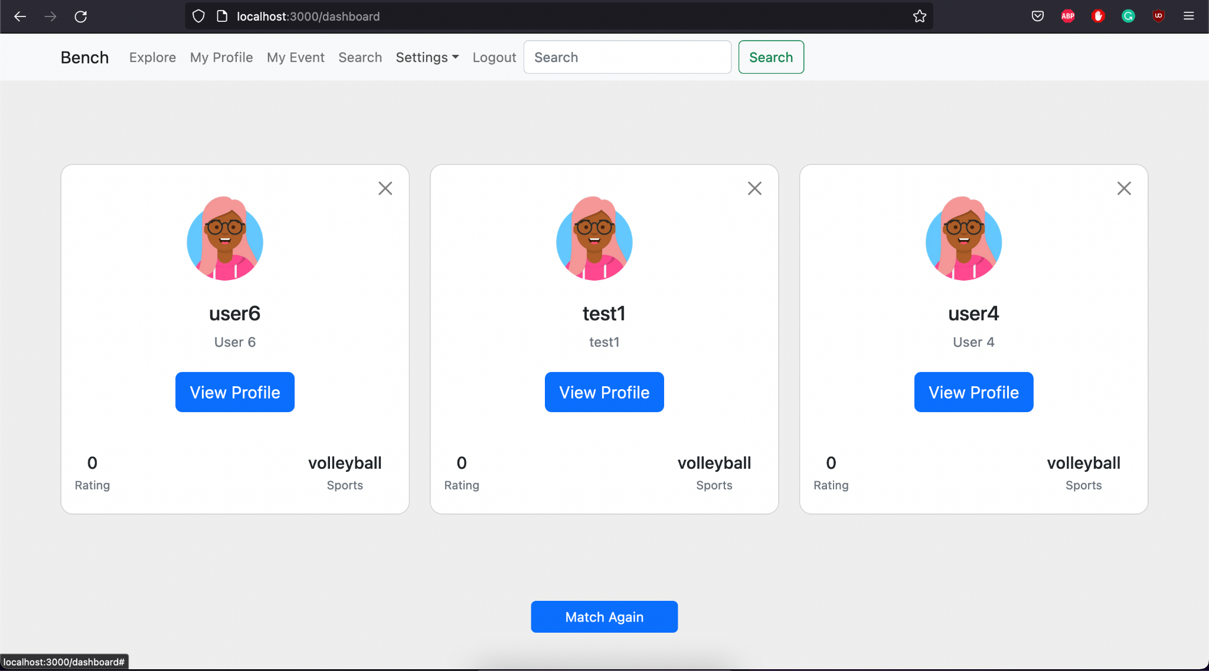

**Test2**

1. Start the Bench application.
2. Click the button “Login” on the navigation bar.
3. Enter the email “team23project@gmail.com” into the text field labeled “Email address”.
4. Enter the password “12345678” into the field labeled “Password”.
5. Click the button “Login” below the field.
6. After the screen has loaded, three panels of different users’ profiles should appear, along with a button labeled “Match Again”.
7. Click on the button labeled “Match Again”.

**Expected Result:** Another set of three users’ profile panels would appear to replace the previous set.



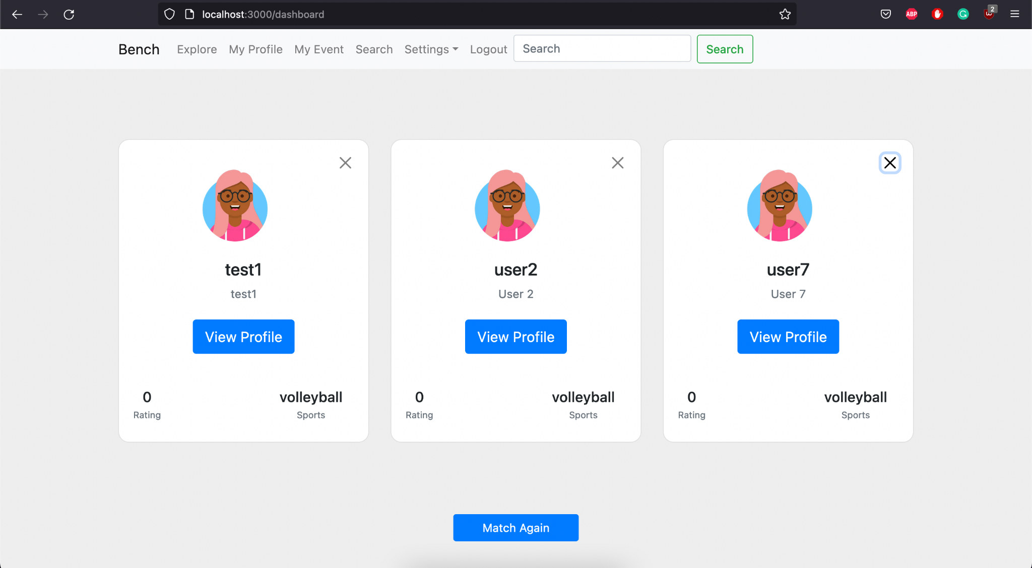

**Test 3**

1. Start the Bench application.
2. Click the button “Login” on the navigation bar.
3. Enter the email “team23project@gmail.com” into the text field labeled “Email address”.
4. Enter the password “12345678” into the field labeled “Password”.
5. Click the button “Login” below the field.
6. After the screen has loaded, three panels of different users’ profiles should appear, along with a button labeled “Match Again”.
7. Click on the button labeled “Match Again”.

**Expected Result:** the button “Match Again” is responsive and changes are applied immediately.



